* Web server is responsible for rendering the user interface and communicating with the server on the user’s behalf. False, Ajax engine (Interaction_models p10)
* …… interprets the document in its logical tree structure thus making it necessary to load a tree representation of the document into memory (yaml - dom – sax) (Introduction p19)
* …. may use an (X)HTML engine to combine dynamic content with (X)HTML templates to generate resulting documents that finally are delivered to the web browser (ajax engine – web server – application engine) (Web_application_aspects p8)
* sax defines the structure and the legal elements and attributes of an xml document. False DTD (Introduction p15)
* internal css defines style for (whole document – whole web site – single html page) **
* to lunch any web applications, you need to have pages, web server and http protocol. (True – False) **
* ….. Stores associated data (cached pages, cookies etc.) (web browser – data persistence – web host) (Web_application_aspects p10)
* …… is a human-readable data serialization language that takes concepts from programming language. (yaml – sax – dom) **
* …… are a standard for TCP-based bidirectional communication channels avoiding these drawbacks. (http 0.2 - Web Sockets – comet) (Interaction_models p29)
* The following is http tag <input type=”text” name=”id” class=”input_text”/> the input_text is …. (css class – attribute value – propriety value) **
* In html5 …. represents content that is only slightly to the rest of the page. (footer – header – aside) (Web_application_aspects p25)
* Web admin need to change …. To launch the hosted web application. (ip – domain allies – dns) **
* ….. is a buzzword for describing modern forms of applications and services that are accessible by the web browser. (web 0.1 – web 1.1 – web 0.2) (Introduction p5)
* ….. means that in order to update the displayed data an http request is sent and the user actions are blocked until an http response from the server was sent. (non-blocking model – synchronous model – asynchronous model) **
* …. Allows users to access updates to online content in a standardized, computer – readable format. (dtd – xml – rss) **
* Html like xml is a self-describing language. This statement is …. (right – wrong) **
* Which of the following tags are not used in html5 (the two other answers – table tag – font tag) **
* Web applications can be described as internet application and vise verse. (yes – no)
* ….. is a high degree of standardization and stricter syntax leads to further unification of browser engine. (script engine – xhtml – ajax) **
* ….. can reuse a connection multiple times to download images, scripts, style sheets, etc after the page has delivered. (http 1.1 piplining – http 1.1 – http 1.0)
* ….. creates a client descriptor which is the endpoint of a communication path to the client and passes it to the delegation process. (delegation process – connector entity – web server) (Web_application_aspects p7)
* Non textual information such as digitized photos or graphic images is not a physical part of …. (web page – html – web host) **
* For ajax technology json is faster and easier than xml. This statement is …. (right – wrong) **
* …. Is software that makes resources available through an interface that is accessible by http. (web server – web browser – interaction model) **
* 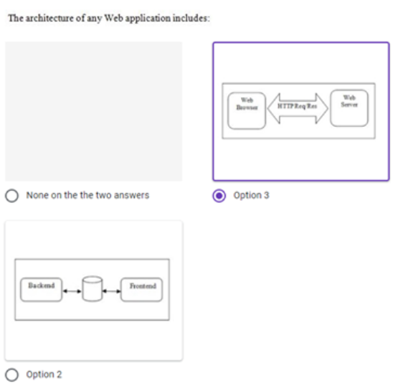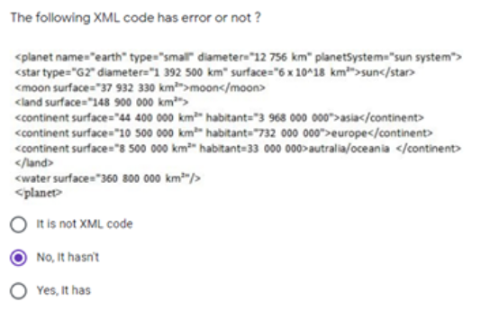….. used to talk about a resource without implying its location or how to access it. (url – urn – uri) **

